1.Install Junit(4.12), Hamcrest(1.3) with Eclipse and Install Eclemma with Eclipse

下载Junit-4.12.jar、hamcrest-core-1.3.jar、和hamcrest-library-1.3.jar。

打开eclipse，新建一个project，在eclipse的菜单栏中，选择Project->Properties，在弹出的框的左侧选择“Java Bulid Path”，然后点击“Add  External  JARs”,把下载的几个包添加进来。如图

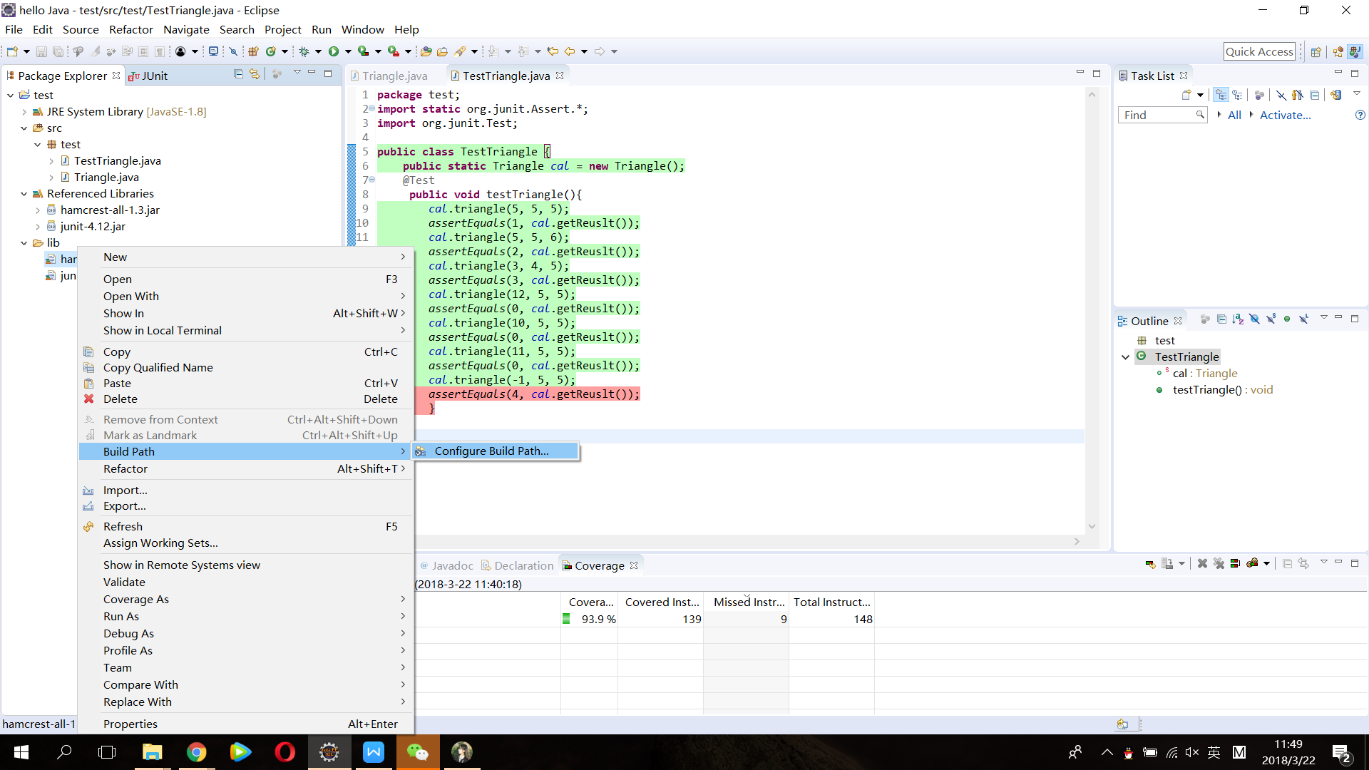

EclEmma直接在eclipse商店中安装即可。

2.java代码

package test;

public class Triangle {  
private static int res=0;  
public int getReuslt(){  
return res;  
}  
  
public void clear(){  
res = 0;  
}  
public void triangle(int a, int b, int c) {  
// TODO Auto-generated method stub  
if(((a+b)>c) && ((a+c)>b && (b+c)>a))  
{  
if((a == b) &&(a == c))  
{  
res=1;//equilateral  
}  
if((a==b && a!=c)||(a==c && a!=b)||(b==c && a!=b))  
{  
res=2;//isosceles  
  
}  
if(a!=b && a!=c && b!=c)  
{  
res=3;//scalene  
}  
}  
else  
{  
res=0;//三边长度无法构成三角形  
}  
  
}  
  
}

3.测试代码

package test;  
import static org.junit.Assert.\*;  
import org.junit.Test;

public class TestTriangle {  
public static Triangle cal = new Triangle();  
@Test   
public void testTriangle(){   
cal.triangle(5, 5, 5);  
assertEquals(1, cal.getReuslt());  
cal.triangle(5, 5, 6);  
assertEquals(2, cal.getReuslt());  
cal.triangle(3, 4, 5);  
assertEquals(3, cal.getReuslt());  
cal.triangle(12, 5, 5);  
assertEquals(0, cal.getReuslt());  
cal.triangle(10, 5, 5);  
assertEquals(0, cal.getReuslt());  
cal.triangle(11, 5, 5);  
assertEquals(0, cal.getReuslt());  
cal.triangle(-1, 5, 5);  
assertEquals(4, cal.getReuslt());  
}  
  
}

4.测试结果截图如下

